**CP Club 365 Days Challenge**

**Programming language – C++**

**Problem Statement**

<https://www.codechef.com/problems/CHEFCBA>

Git :- <https://github.com/Vedantbharad2603/CP_club_365_Days>

**Your Code**:

// 0x118Day of 0x365Days challenge

// VEDANT BHARAD

// 12-2-2023

#include<bits/stdc++.h>

using namespace std;

int main() {

    // your code goes here

    int a,b,c,d;

    cin>>a>>b>>c>>d;

    if(a*c==b*d || a*b==c*d || a*d==b*c)

        cout<<"Possible"<<endl;

    else

        cout<<"Impossible"<<endl;

    return 0;

}

**Output (Screen Shot)**:

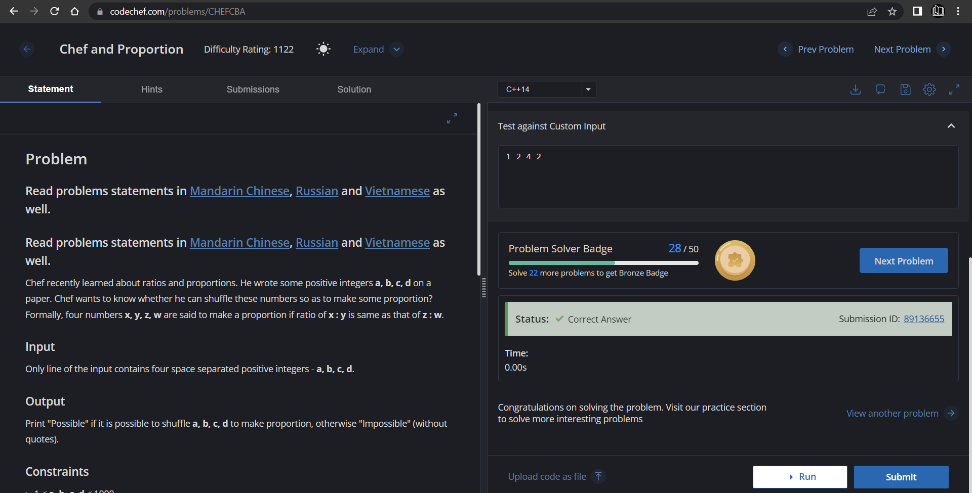

**Understanding about problem:**

* In this task I need to find ratios in between given four number if there is then return Possible else return Impossible.

Note: If you can't understand the problem, feel free to contact us and we'll help you. Please don't copy and paste from anywhere.

ALL THE BEST

Team CP Club